### **Hobby App**

### 

### **Aim:**

Create a user-friendly UI for a hobby app in Figma, focusing on intuitive design for tracking and managing hobbies, including features like a dashboard, hobby list, activity tracking, and social integration.

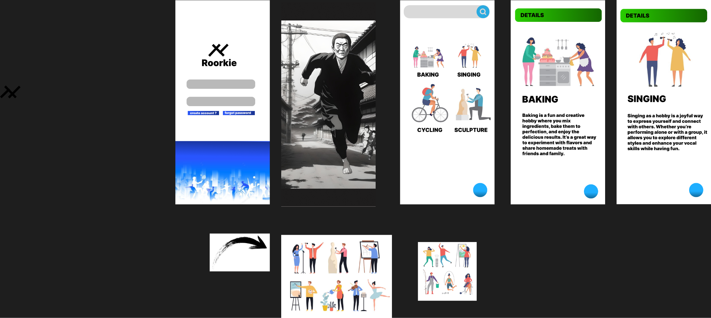

### **Procedure:**

**Created a New Figma File:** I started by creating a new file in Figma and set up frames for all the key screens, such as Home, Hobby List, and Settings.

**Defined My Design System:** I chose a color palette and typography that fit the app’s theme. Then, I created reusable components like buttons, input fields, and cards to maintain consistency.

**Designed Each Screen:** I used the components I created to design the individual screens, making sure everything was aligned and easy to navigate.

**Added Interactions:** I linked the screens together and set up basic interactions, like buttons leading to new pages and smooth transitions between screens.

**Tested and Iterated:** After prototyping, I tested the flow by clicking through the app and made changes based on how it felt and any feedback I got.

### 

### **Result:**

### A complete, polished UI design for the hobby app with a functional prototype that users can interact with. It includes screens for managing hobbies, tracking progress, and social features, all designed with consistent style and usability in mind.